CONNECTICUT JCI SENATE SUMMER PICNIC
MEETING/SOCIAL
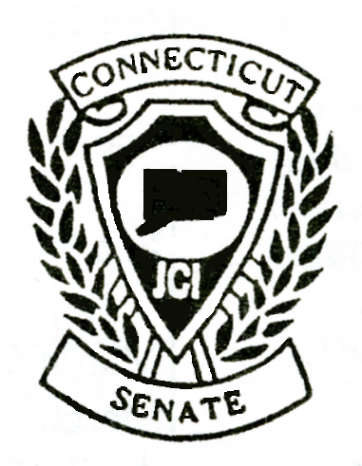
SATURDAY
July 15, 2017

12 NOON TO 5 PM

VFW KARI-HILL POST 5849
39 COLUMBUS AVENUE
NIANTIC, CT 06357

MENU

CHOICE OF: LOBSTER OR STEAK

CORN ON THE COB; HOT DOGS/HAMBURGERS SALAD;
BEER, WINE, SODA, WATER

ETC.
STEAK
LOBSTER

Please mark your choice of lobster or steak

Name: _____________________________________ Senate # ______________

Spouse/Guest: _______________________ Senate/FR # _____________

E-Mail Address:

Number Attending: _____ @$26.00 per/person Amount: $ ________________

Registration deadline: July 8, 2017
Make checks payable to Connecticut JCI Senate and mail to:

Jack Pasquale, Senator #32806
21 Prospect Avenue
Niantic, CT 06357

Contact Jack Pasquale for any questions; jci32806@att.net or phone 860 739-6342; 203 824-2517

Beach access; Short business meeting; Bring a lawn chair/beach chair;
Social after the picnic at the home of Sue and Jack

Last names starting with A through M are asked to bring an appetizer.

Last names starting with N through Z are asked to bring a dessert.

